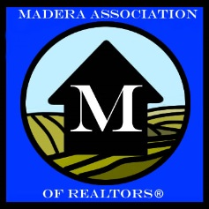
What We Do Matters
Our Mission Statement
The Mission of the Madera Association of REALTORS is to help our members reach their career potential and support them in bringing this potential to our community.
- To promote standards of competence and ethical practice in the field of real estate;
- To encourage increased recognition of professional education in real estate;
- To enhance the value of belonging to Madera Association of REALTORS;
- To protect private property rights and promote homeownership.

